Q1.Perform the following:

a.Create a form with content canvas

b.register the above created form as function

c.Create a menu

d.add the above created function to the above created menu

e.Create responsibility

f.attach the above created menu to the above created responsibility

**OUTPUT:**

**STEP1: Copy APPSTAND.FMB,TEMPLATE.FMB all .pll files to local machine**

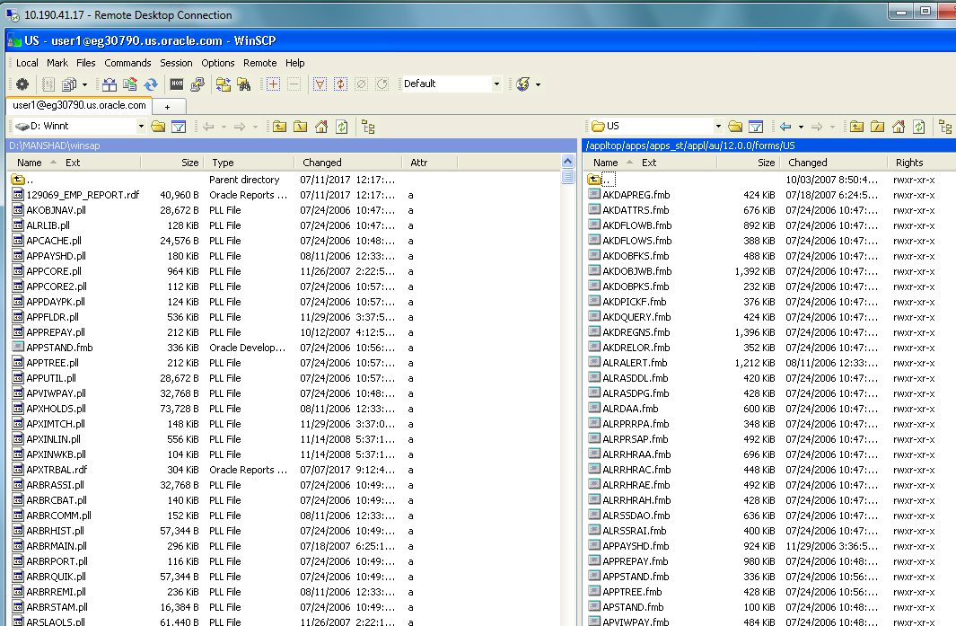

**STEP2: Registering the form**

**Go to START🡪RUN🡪REGEDIT**

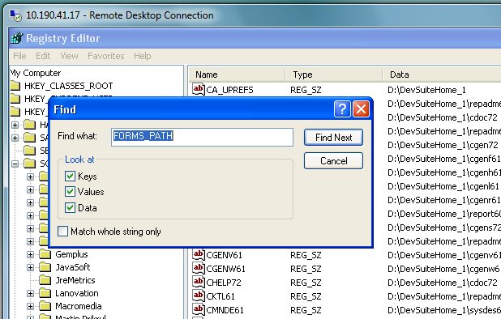

**STEP3: PASTE THE LOCAL MACHINE PATH in edit string**

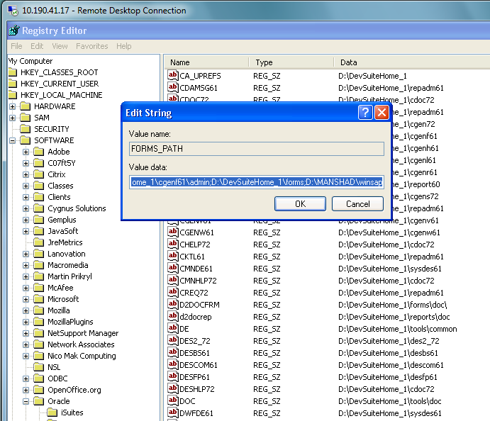

**STEP4:OPEN APPSTAND.FMB and TEMPLATE.FMB in Form builder**

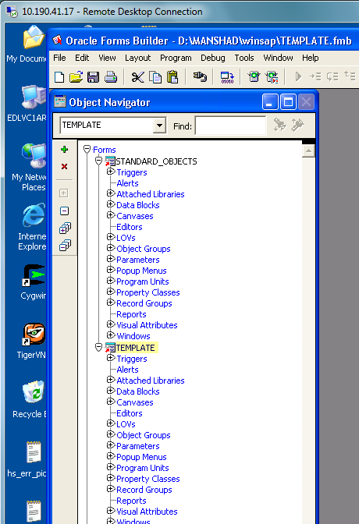

**STEP5: RENAME TEMPLATE AS EMP_SAL**

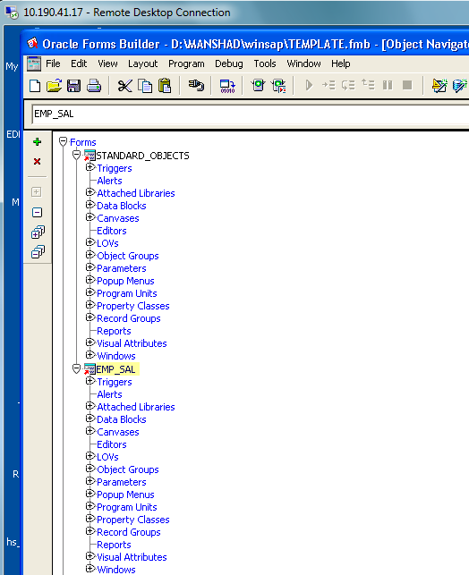

**STEP6:DELETE BLOCKNAMES IN CANVAS,WINDOWS,DATABLOCKS**

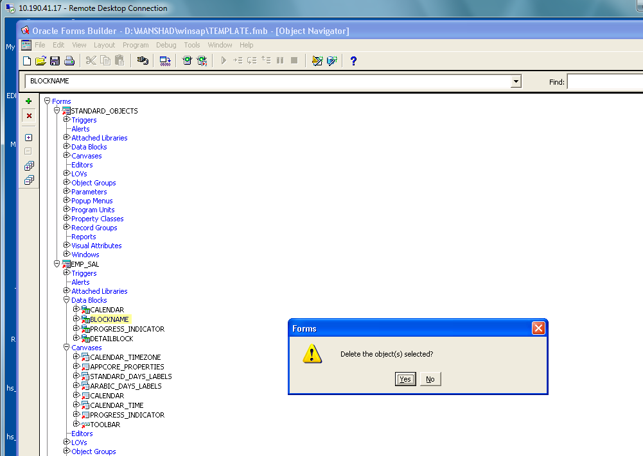

**STEP7: CREATE A NEW BLOCK IN DATABLOCK using WIZARD**

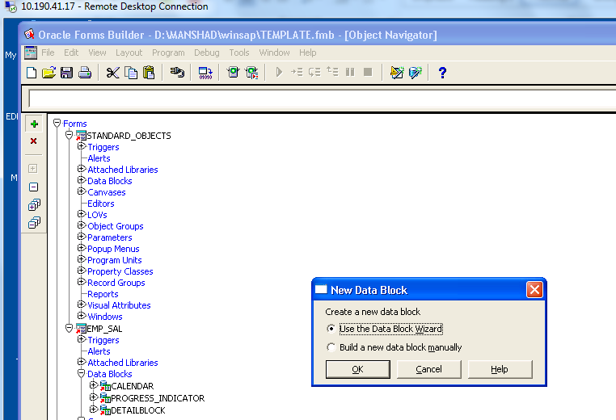

**STEP8:CREATED FORM IS**

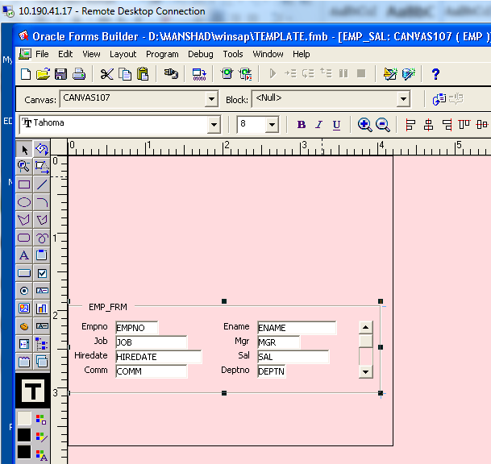

**STEP9:** Select the frame and navigate to frame properties. There change the frame name to “EMPLOYEE_FRM” Subclass : Property class to FRAME_RECT Update

**Layout – manually**

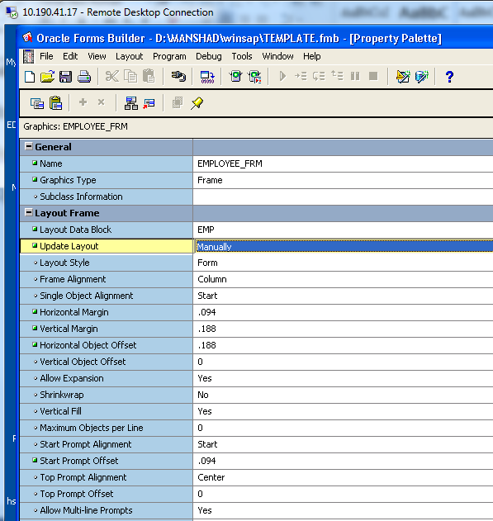

**STEP10: SAVE AND EXIT THE FORM, NOW CREATE A NEW WINDOW, :** Navigate to Property class of the window and change the name to EMPSAL And subclass to window

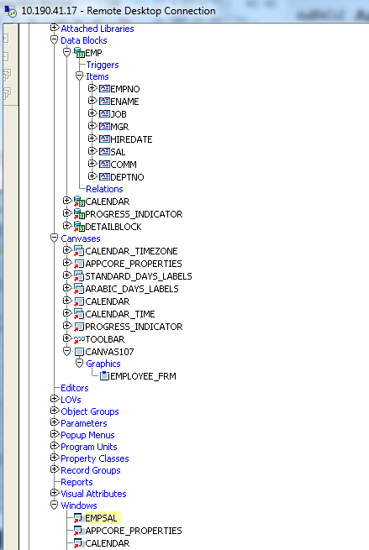

**STEP11:** Now switch to canvas Change the canvas name to EMPSALSubclass to Canvas And Window to ESAL

**STEP12**: Now EMPSAL in the canvas is dragged on to the top of the window

**STEP13: :** Navigate to Block and change the block name to EMP_SAL and the Subclass name to Block

**STEP14:** Now Pre-form Triggers are to be Set and the changes are to be made as shown **Template Form to CUSTOM EMPSAL FORM** **FND to CUSTOM** **Author to : TEST_USER_VVB**

**BLOCKNAME to EMPSAL**

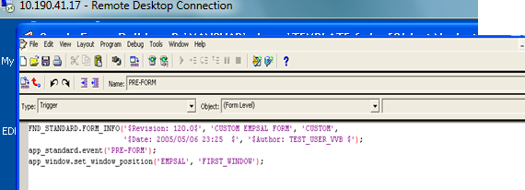

**STEP15:NOW SAVE AND COMPILE**

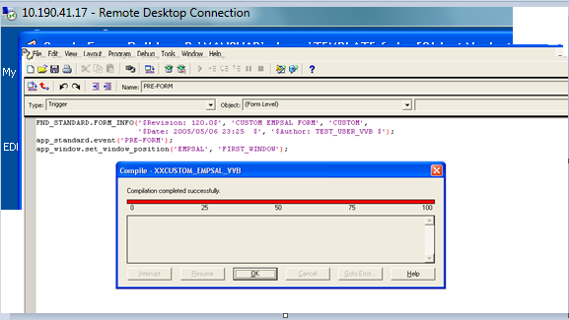

**STEP16:** Switch to program unit and navigate to BODY and change the assigned window name and save it

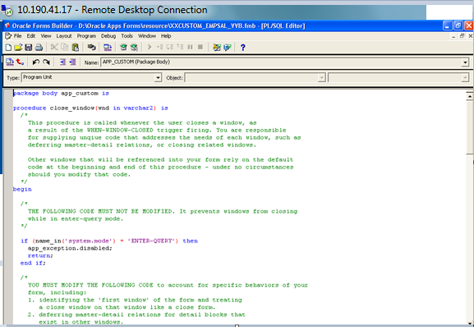

**STEP17:COMPILE**

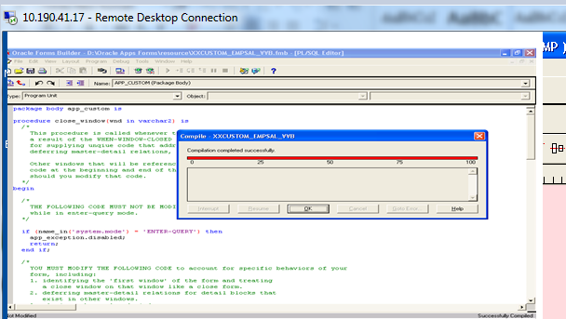

**STEP18: NOW COMPILE THE ENTRIE FORM**

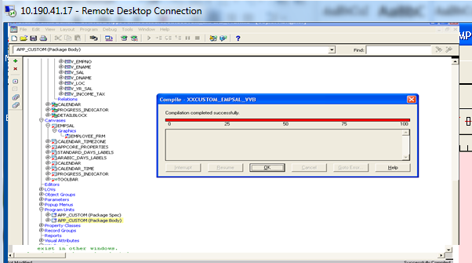

**STEP19:NOW COPY THE FORM TO THE ORACLE SERVER PATH**

**/dbfiles/applcsf/cust/forms/US**

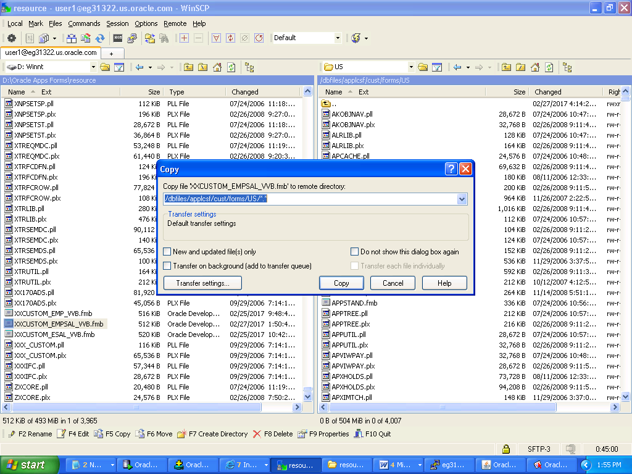

**STEP20: NOW GO TO PUTTY** type the following commands

$ cd $CUST_TOP/Forms/US

$ frmcmp_batch Userid=apps/apps Module=xxcustom_empsal_vvb.fmb

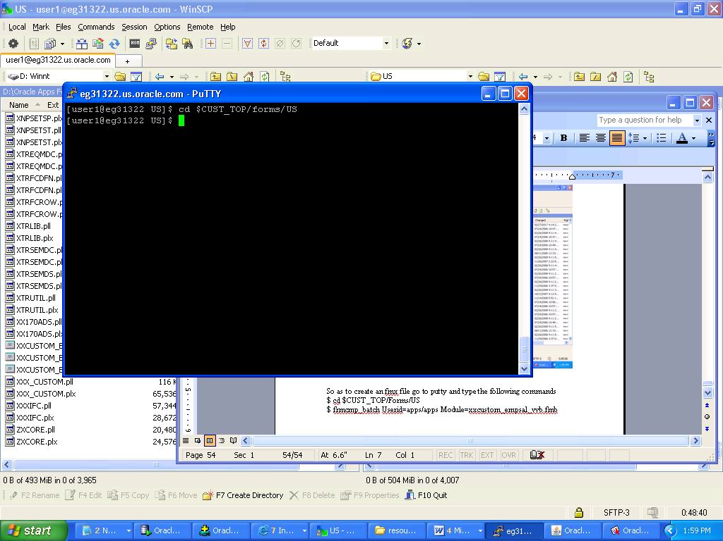

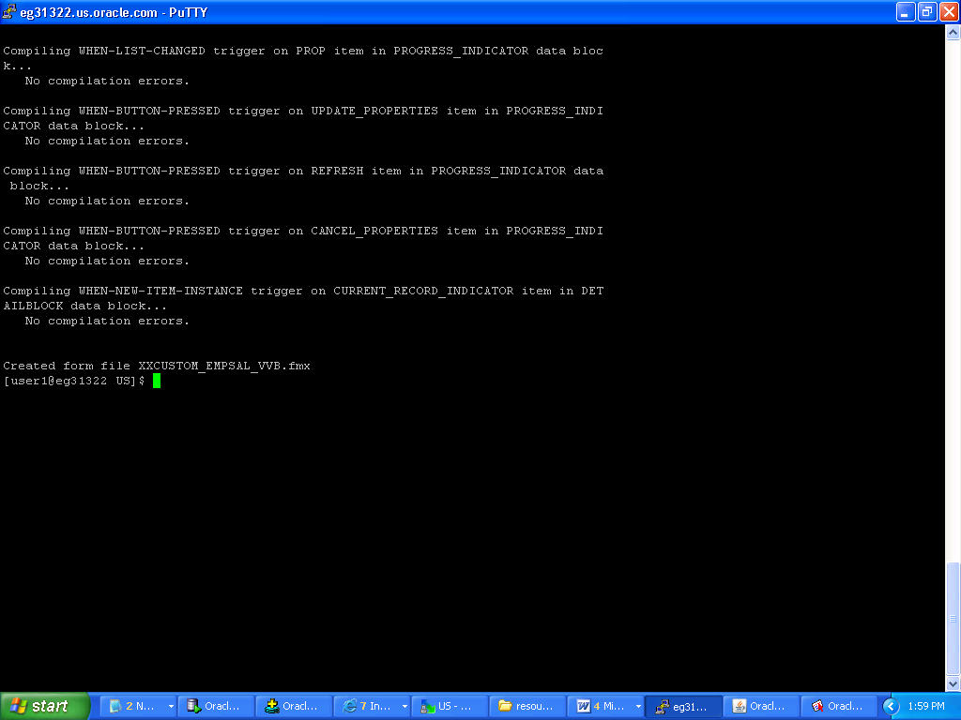

**STEP21**: Now the fmx file is created.

The file is ready to be assigned to custom responsibility

Switch to Oracle application Forms:

Switch responsibility to Application Developer

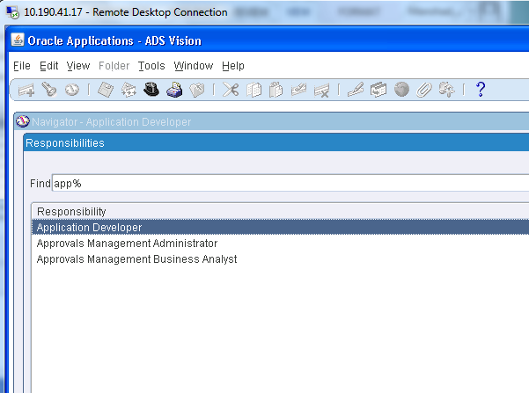

**STEP22**: Navigate to Application and Form, Here create a new form with the following inputs: 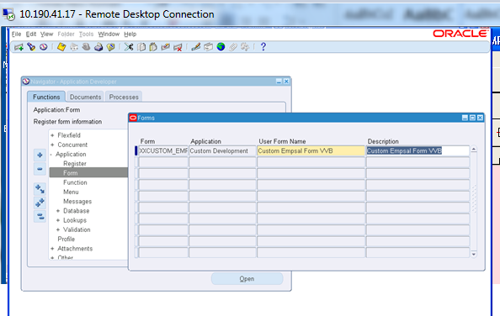

**STEP23:CREATE A FUNCTION**

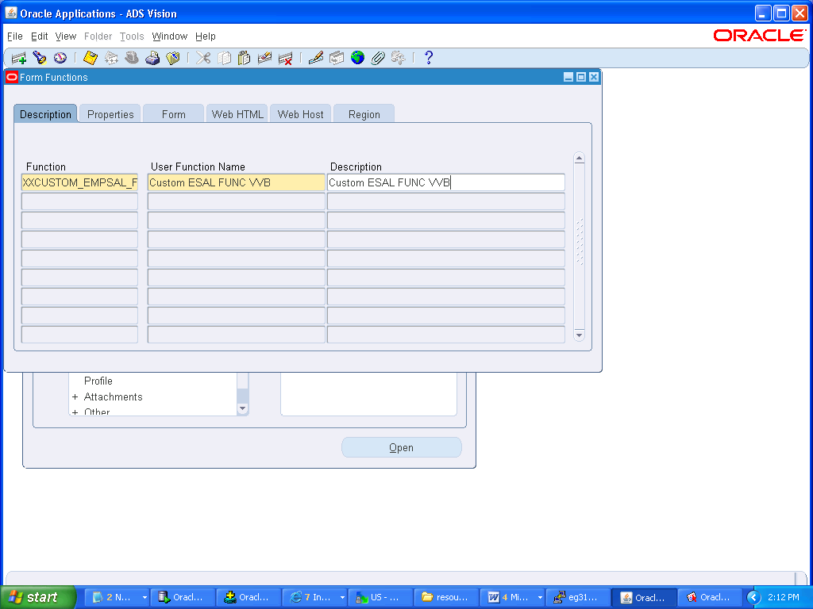

**STEP24:** In Properties tab

FORM – >Form

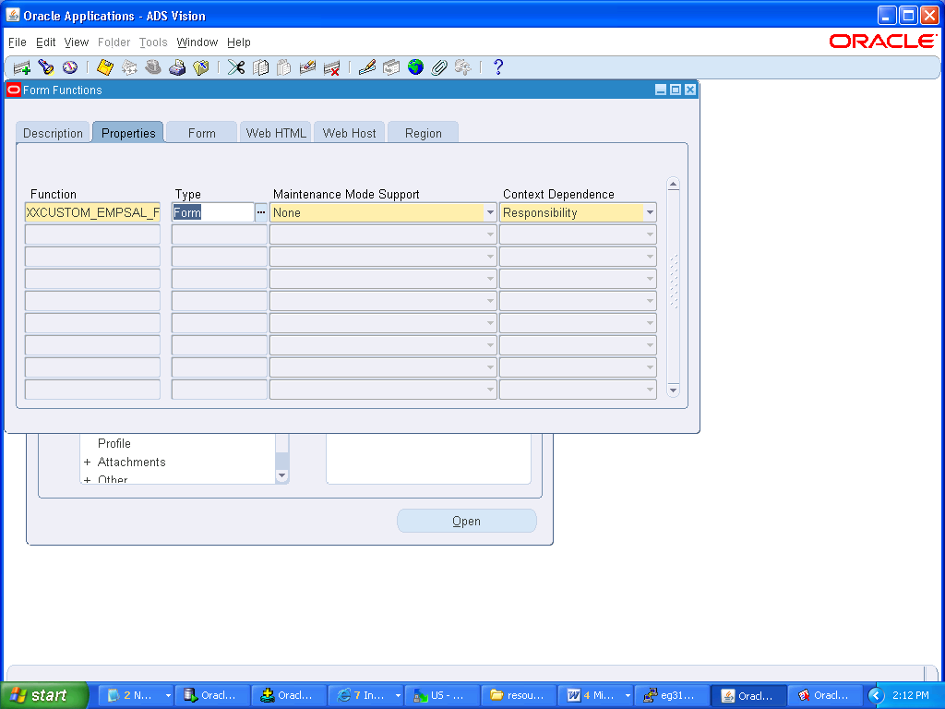

**STEP25:** In FORM Tab-

Form- query the record and enter CUSTOM EMPSAL FORM VVB

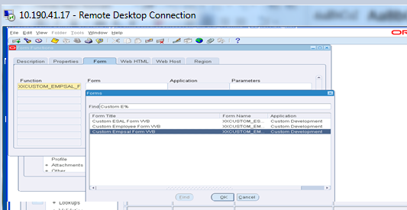

**STEP26:** Now the form is to be attached to the custom menu

Navigate to menu

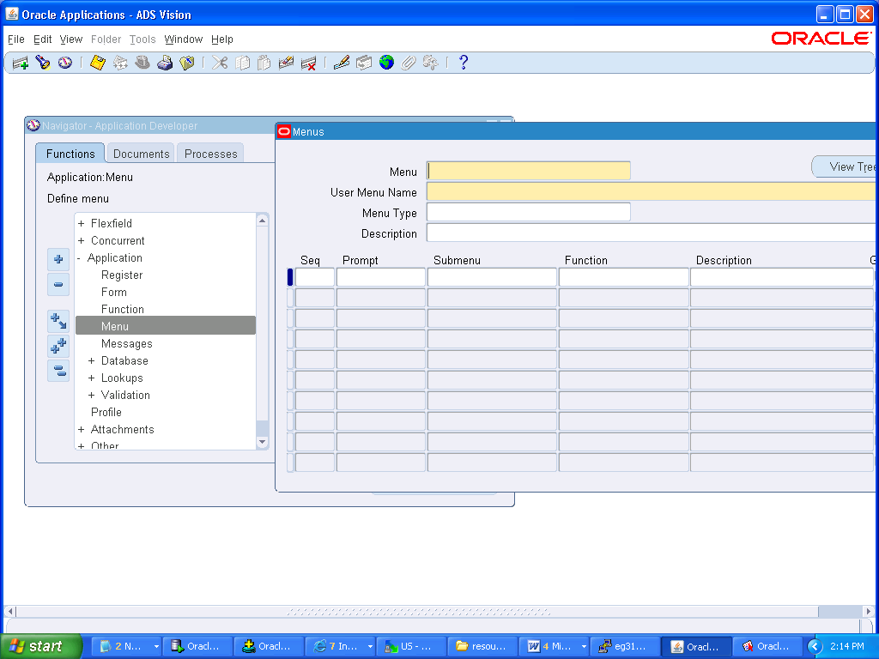

**Step 27:** Query the menu with name and add the created function

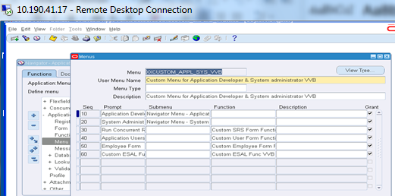

**Step 28:** Now save and exit the Form

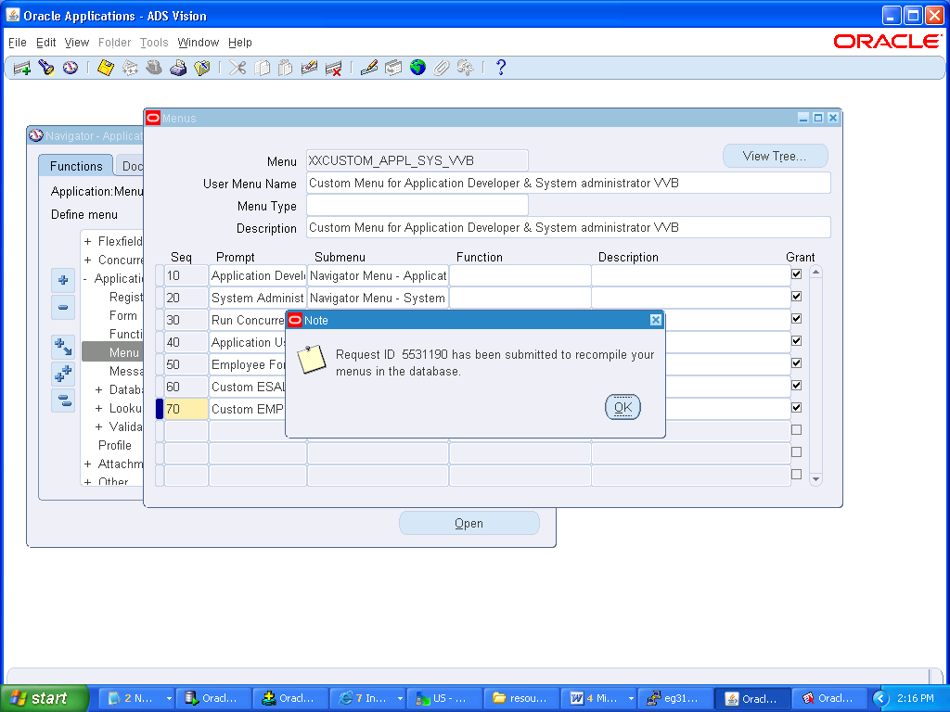

**Step 29:**Now Switch to custom responsibility

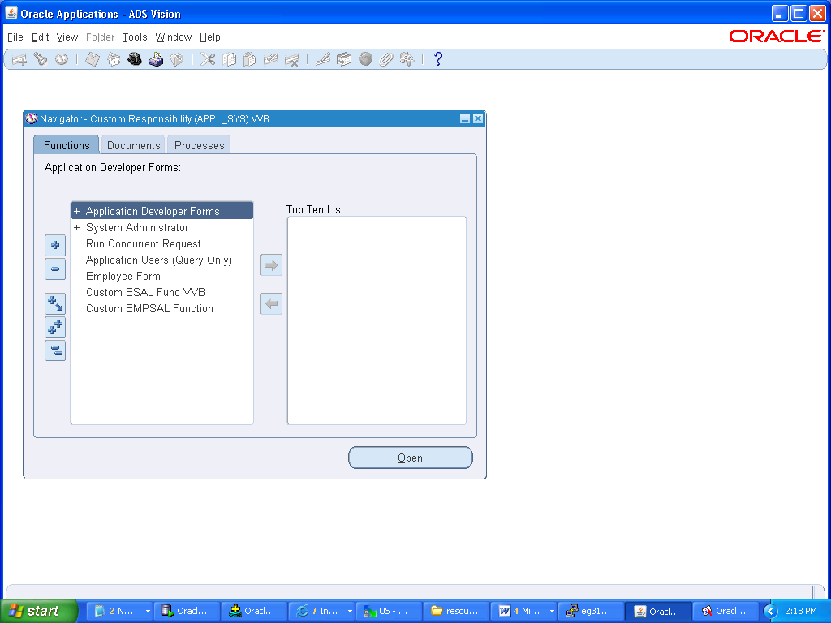

**Step 30:**Then run the form by selecting view -> query by Example -> Run

